MOVIE SCREENING AT RAVINDRA BHAVAN, BAINA –VASCO

The Psychology Department of M.E.S College of Arts & Commerce, Zuarinagar-Goa in collaboration with South Goa Zilla Panchayat and Ravindra Bhavan-Baina screened a film, ‘Zindagi Zindabad’ for the M.E.S College and Higher Secondary students of Mormugao taluka on the 3rd of October 2019 at Ravindra Bhavan, Baina –Vasco. Dr. Mohan Agashe, renowned actor, director, producer and psychiatrist was the Chief Guest for the event. At the inaugural function, Ms. Cedila Pereira e Gomes, H.O.D in psychology welcomed the gathering and introduced the dignitaries. The Guests of honor were Dr. Angelica Siona Gomes, Project Director, Goa State Aids Control Society Shri. Navnath Naik, Chairman, South Goa Zilla Panchayat, Shri. Agnelo Fernandes, Chief Executive Officer, South Goa Zilla Panchayat and Mrs. Nelly Rodrigues, Chairman of Panchayat Mahila Shakti Abhiyan and member of South Goa Zilla Panchayat and Shri. Sanjay Satardekar, Chairman , Ravindra Bhavan, Baina.
The film ‘Zindagi Zindabad’ is like a jigsaw puzzle. When all the pieces are put in place there emerges a complex picture of interconnected Indian society trying to co-op with pandemic of HIV-AIDS. The film is a fiction based on research of the stark reality. The final experiential message for the audience is: Life is a precious gift & let us understand its importance and at the same time let us not condemn the ones who are unfortunately affected by this decease by judging them but in fact let us be compassionate to them & give them love.
The movie screening was followed by a discussion by the panel of experts headed by Dr. Mohan Agashe. The movie was witnessed by a houseful of over 750 students from M.E.S College, Higher secondary schools and program officers from various NGO’S working in the field of HIV/AIDS like Presentation Society, Zindagi etc.

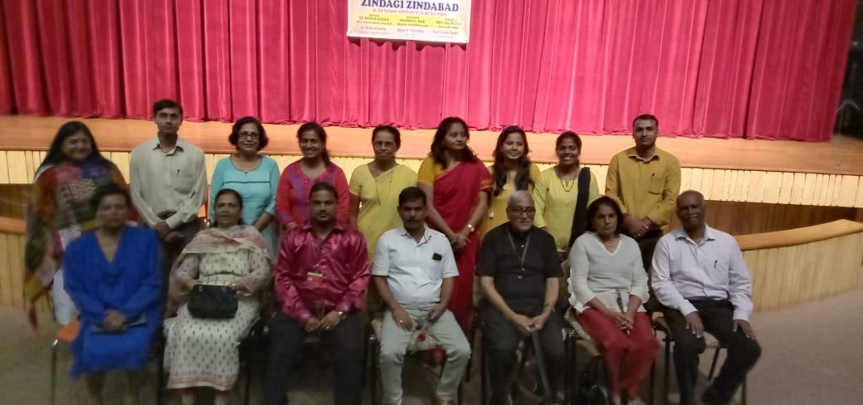

Standing from fourth left- Ms. Cedila Pereira e Gomes, H.O.D, Psychology Department and
Co-ordinator of the program and Officiating Principal Dr. Rekha Gaonkar.
Sitting – Mrs Nelly Rodrigues, Chairman of Panchayat Mahila Shakti Abhiyan and member of South Goa Zilla Panchayat, Mrs. Lalita Joshi, Director, Planning and Development , Murgaon Education Society, Shri. Agnelo Fernandes, Chief Executive Officer, South Goa Zilla Panchayat, Shri. Navnath Naik, Chairman, South Goa Zilla Panchayat, Dr Mohan Agashe, Chief Guest, Dr. Angelica Siona Gomes, Project Director, Goa State Aids Control Society and CMO, Goa State Aids Control Society.

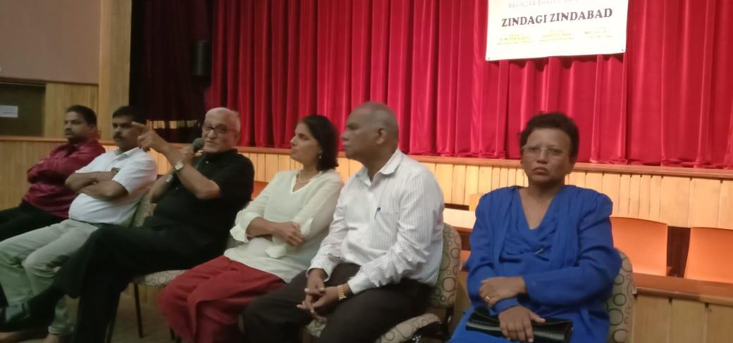

From left to right- Shri. Agnelo Fernandes, Chief Executive Officer, South Goa Zilla Panchayat, Shri. Navnath Naik, Chairman, South Goa Zilla Panchayat, Chief Guest, Dr.Mohan Agashe, Dr. Angelica Siona Gomes, Project Director, Goa State Aids Control Society, CMO, Goa State Aids Control Society and Mrs. Nelly Rodrigues, President, South Goa Mahila Mandal and member of South Goa Zilla Panchayat.

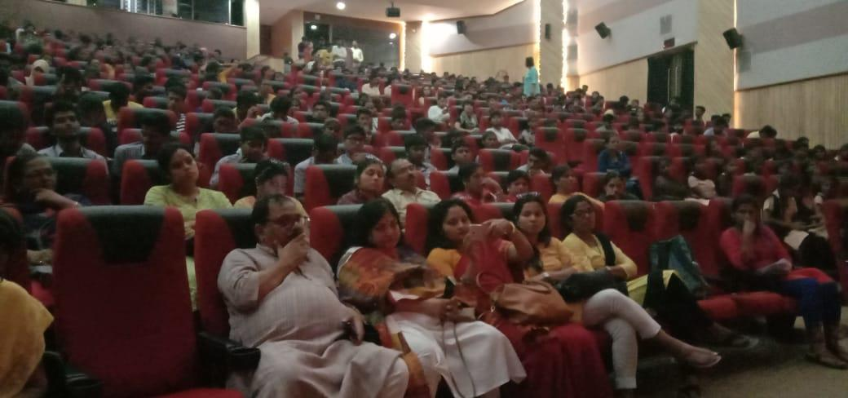

The audience listening with rapt attention to the panel discussion at the movie screening of ‘Zindagi Zindabad’.

